Welcome!
St. Paul’s Community Christian Church
Pastor Ed Dickerhoof
May 11, 2025
Gathering Music
Joyful, Joyful
Great Is Thy Faithfulness

Welcome
Prayer

Music
Come Thou Font
How Great Thou Art
Be, Thou My Vision

Scriptures: Jonah 1:1-4:11
Message – Rebecca Prewett
“Sunday School Revisited: Jonah”

Music
Holy, Holy, Holy Lord God Almighty

Pastor Ed Dickerhoof 330-704-4638
Church Phone 330-488-0189
Beth Schuring – Prayer Chain 330-327-8481
Church Email - stpaulsccc@stpaulscccec.com
Website – www.stpaulscccec.com
Facebook – www.facebook.com/St.PaulsCCC.org
YouTube – https://www.youtube.com/@St.PaulsCommunityChristianChur

Sunday School Revisited: Jonah

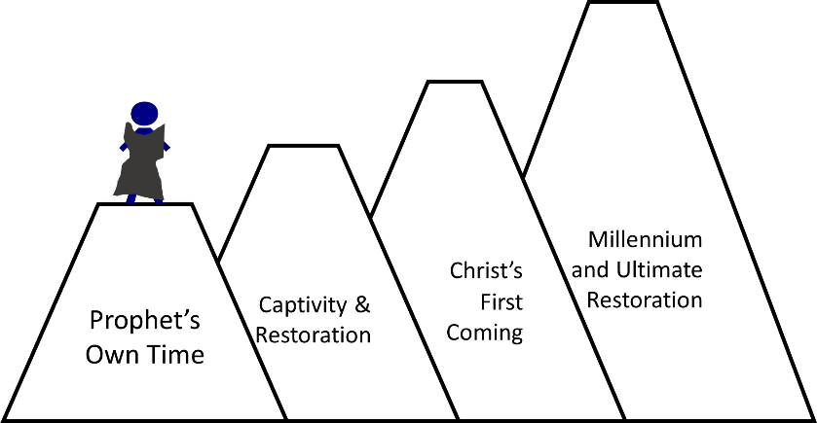:

References
- https://www.myjewishlearning.com/article/jonah-the-jew/
- https://www.myjewishlearning.com/article/jonah/
- https://jewsforjesus.org/yom-kippur
- Cultural Backgrounds Study Bible
- Complete Jewish Study Bible
- Jewish Study Bible
- ESV Study Bible

